**USER GUIDE**

**E-PROJECT**

**PASCAL IMITATION**



  PASCAL IMITATION

*User Guide*

|  |  |  |
| --- | --- | --- |
| **Supervisor.** | **Miss Quratulain Haider** | |
| **Batch.** | **2406El** | |
| **Group.** | A | |
| **Serial No.** | **Enrollment Number** | **Student Name** |
| 1. |  |  |
| 2. |  |  |
| 3. |  |  |
| 4. |  |  |

***https://lh7-rt.googleusercontent.com/docsz/AD_4nXdak2fQgcPeepPHIT3HOBAzr6nrU7X6VzzxUpqBd3Wu6ydszyAmjAbCMMWhQCL4z5MA8YedAgEgXDG3zWMBOkE5A-ffEMusmAZ6vtIDUNPgvr-BS9JliGp43fDYmPW0P1a64JwpdWZMuxMyeNUNs57axIMXCqCSYNcZk0IJmw?key=KhdWeQ31oyKcQm8GJSGblk6n***

1. **Home**

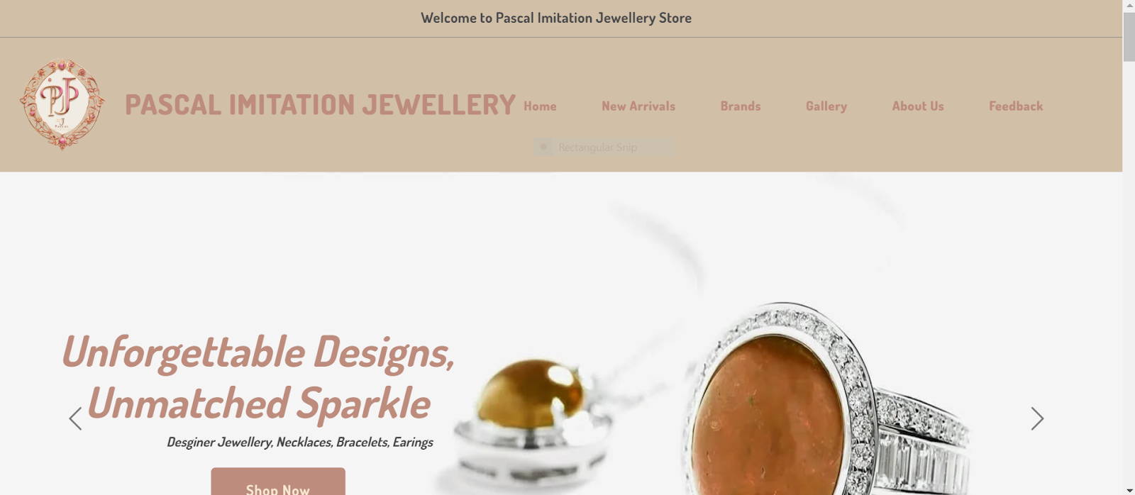

***Figure 1: Home page to Pascal Imitation***

Arrow Slight curve  Our Slogan has given to the peoples toward our website. “Unforgettable Designs, Unmatched sparkle”.

* By clicking (**home)**button user while redirect to the main webpage.

**Navbar**



***Figure 2: Navbar***

We have given seven essentials. By clicking any of the essential’s and redirect to the linked page.

1. **About us**

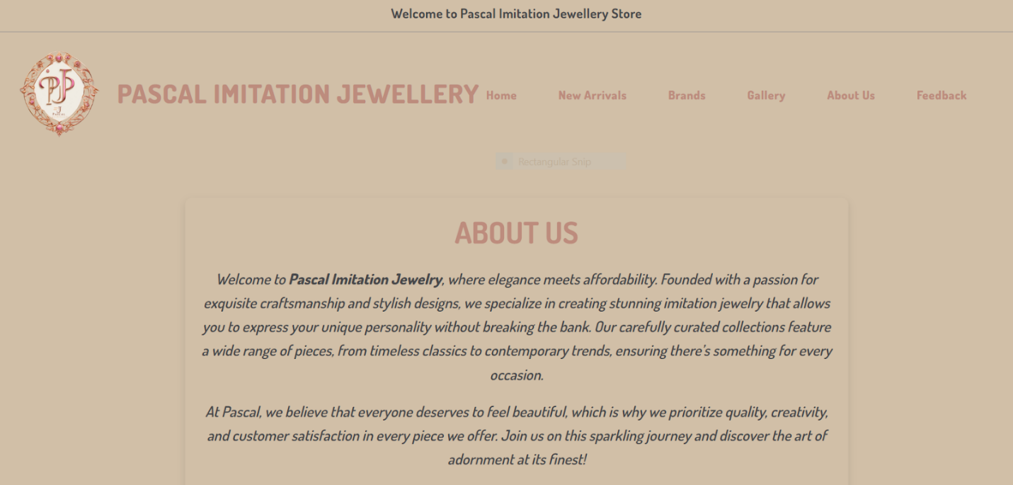

***Figure 3: About us***

*https://lh7-rt.googleusercontent.com/docsz/AD_4nXcpT3zCrBw7DxyonUnd0wusBnpZgkmLLPf8YCWQ7I47oGIaVo7arBuDSJASIKTP4oplFgVvxFJjpM7KwUBfoyM02AwvhycbrG8eFDfCwjw8eLD5ZUPrgHkfDXLSrN8Dill_IYd0MJczV3sRcM2q9KBpFZUSuGJGJysWWCmMlw?key=KhdWeQ31oyKcQm8GJSGblk6n*

https://lh7-rt.googleusercontent.com/docsz/AD_4nXc0bmk9ugrbToX3gI9GgVBLrvYHD1Lbc3m1MgpuyYVxQhSVkfayb1o5ptf2SBkWA2aHWKg1-3Gh-BFHzrfWFyv9yRjp5gL8GPBEJqoyHpMaQ26IJIJLgRAdi_lb2S3bDPVXEFQSOK7Cu0HotHjxbR6IyZiO4M0Bu-NtnW1YwA?key=KhdWeQ31oyKcQm8GJSGblk6n

*Arrow Slight curve*  Welcome to **Pascal Imitation**, where elegance and affordability meet in a dazzling array of jewelry. Founded with a passion for style and quality, our website offers something special for every jewelry lover. Our carefully curated brands – **Velvet Elegance**, **Velvet Vault**, and **Velvet Sparkle** – each bring their own unique aesthetic, from timeless pieces crafted with precious and semi-precious gems to stunning, high-quality artificial jewelry. We believe in making luxury accessible, so whether you're searching for an everyday staple or a statement piece for a special occasion, Pascal Imitation delivers elegance that resonates with every taste and budget. We’re committed to offering superior quality, transparent service, and a seamless shopping experience, empowering you to shine in every way.

**4.Brands**

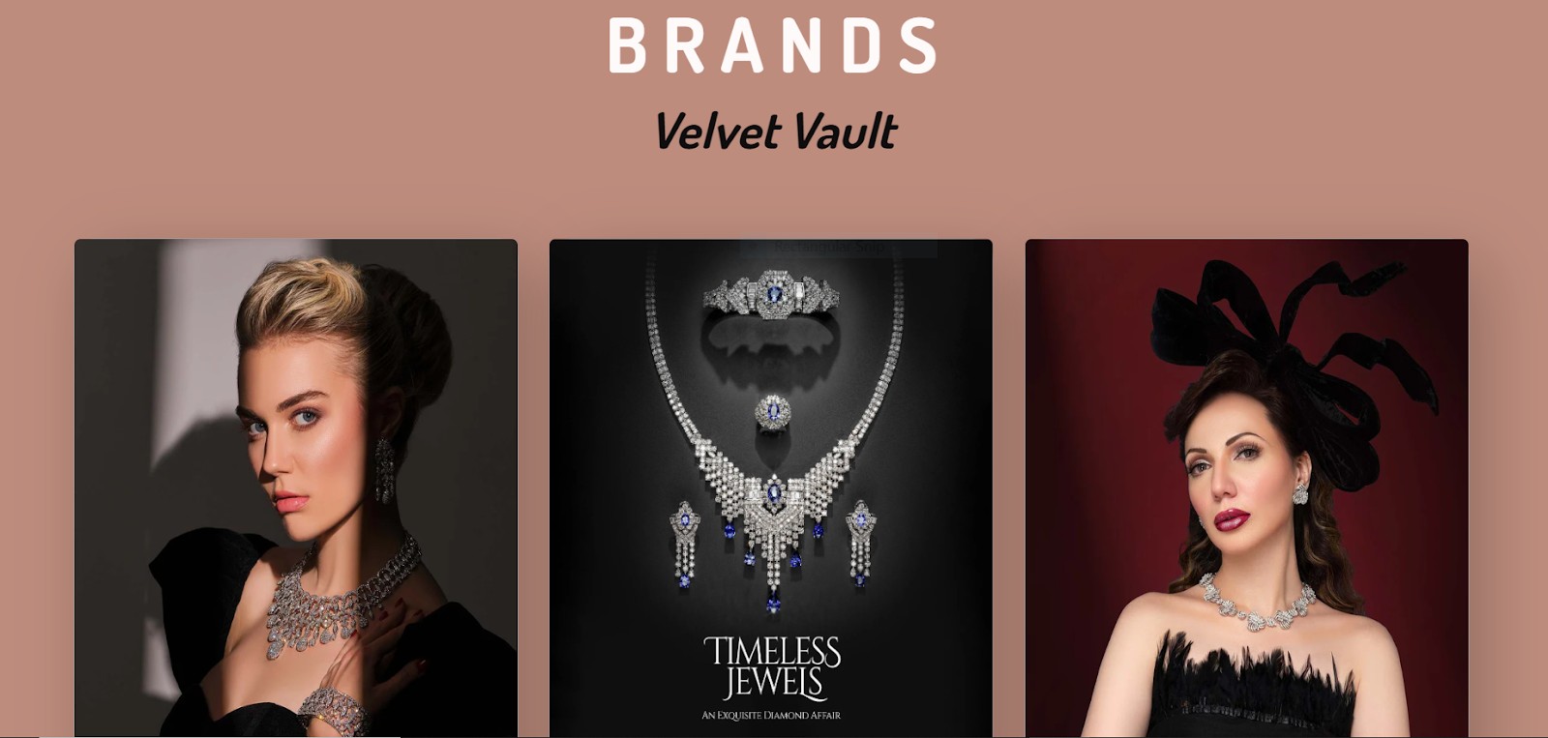

***Figure 4: Brands***

At Pascal Imitation, we pride ourselves on offering a curated selection of unique brands that cater to every taste and occasion. Velvet Elegance exudes timeless luxury with its collection of sophisticated, precious jewelry, perfect for those seeking high-end, classic pieces. Velvet Vault offers a blend of modern flair and exquisite craftsmanship, showcasing designs that appeal to fashion-forward individuals with an eye for quality and style. Meanwhile, Velvet Sparkle brings a touch of playful glamour, featuring both original and semi-precious pieces that shine with vibrant charm and elegance. Each brand is dedicated to delivering exceptional quality and craftsmanship, ensuring that our customers experience beauty and luxury in every piece they choose. Whether you’re after something classic, contemporary, or sparkling, our brands promise to meet every jewelry lover’s desires.

***Brands in detail***

***5.Velvet Vault***

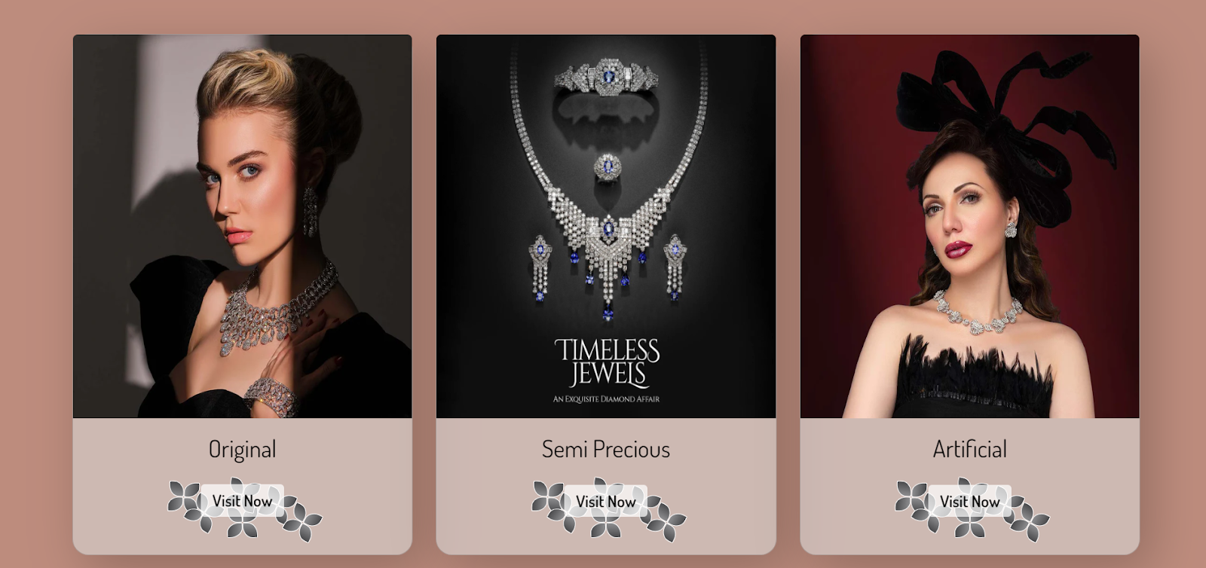

https://lh7-rt.googleusercontent.com/docsz/AD_4nXcOrISALxg1aEgPYawkevkJf7mLBhDIbjKc34bkyU7KUkoYNlVMmZWQfwoqxqOh2G6AsK7-qJyem0S2SSuut0sJMWR4nPI6Xo8DBpFJ-KuHFT8z0H-TMPaTaeu9s96Fevl1-vNk0JfHuTrDjm9g-3QM66-NnQSJWJIkL84WdQ?key=KhdWeQ31oyKcQm8GJSGblk6n

***Figure 5: velvet vault***

Velvet Vault is a brand that blends modern elegance with exceptional craftsmanship, offering a stunning collection of jewelry designed to make a statement. With a focus on innovative designs and fine materials, Velvet Vault caters to those with a keen sense of style and an eye for luxury. Each piece is crafted with attention to detail, ensuring that it not only stands out but also embodies timeless sophistication. Whether it’s a sleek, minimalist design or a bold, intricate piece, Velvet Vault offers versatile options that elevate any look, making it the perfect choice for fashion-forward individuals who appreciate quality and style.

***6.velvet elegance:***

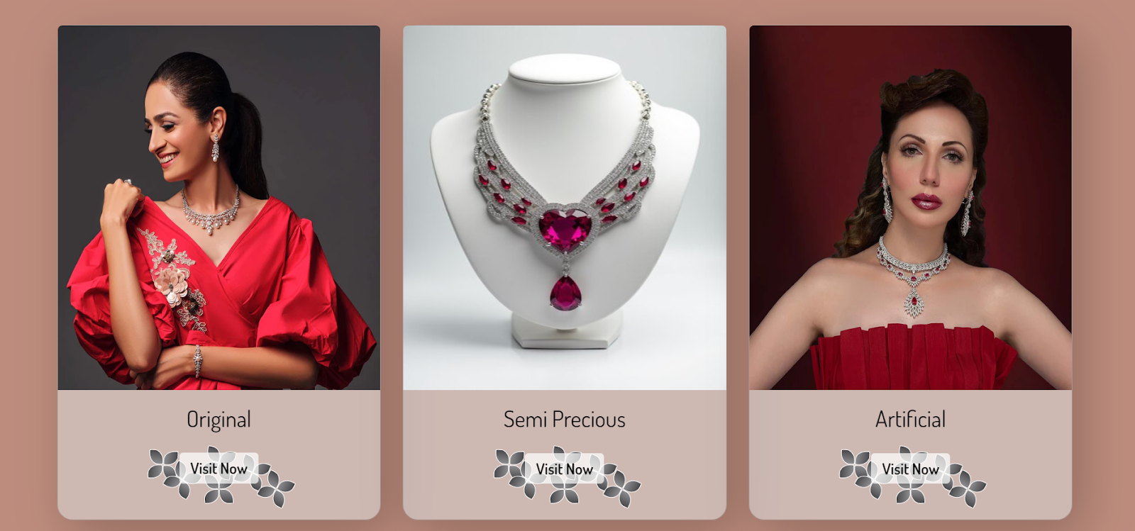

***Figure 6: velvet elegance***

Velvet Elegance embodies the essence of timeless luxury and sophisticated design. This brand is dedicated to offering exquisite, high-quality jewelry crafted with precious and semi-precious gems. Each piece from Velvet Elegance is meticulously designed to capture the grace and beauty of classic styles, while adding a modern touch that makes them perfect for any elegant occasion. Whether you're seeking an heirloom-quality necklace, a stunning pair of earrings, or a statement ring, Velvet Elegance provides the perfect balance of refinement and charm. Ideal for those who appreciate true craftsmanship and the finest materials, Velvet Elegance is the go-to brand for a touch of enduring luxury.

***6.velvet sparkle:***

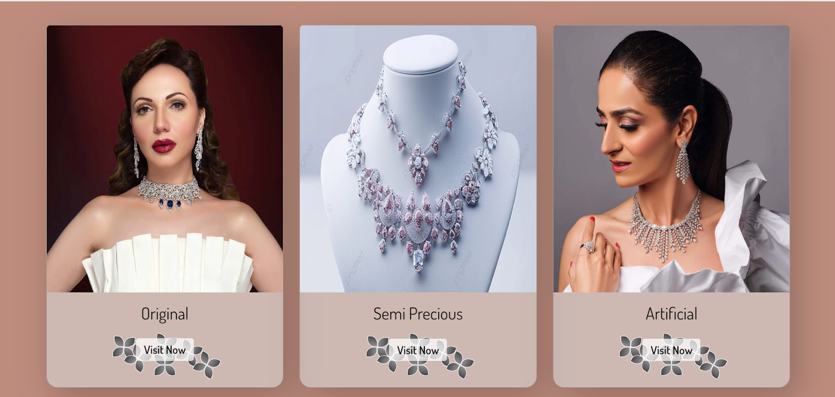

***Figure 6: velvet sparkle***

Velvet Sparkle is where radiant elegance meets playful charm. This brand offers a stunning collection of jewelry that shines with vibrant beauty and sophistication, perfect for those who love to add a touch of sparkle to their look. Featuring a blend of original designs and semi-precious gemstones, Velvet Sparkle captures the essence of glamour, creating pieces that are both fashionable and timeless. Whether you're dressing up for a special event or adding a bit of sparkle to your everyday style, Velvet Sparkle ensures that every piece brings out the best in you, making you feel confident and beautifully unique.

***7. Video link:***

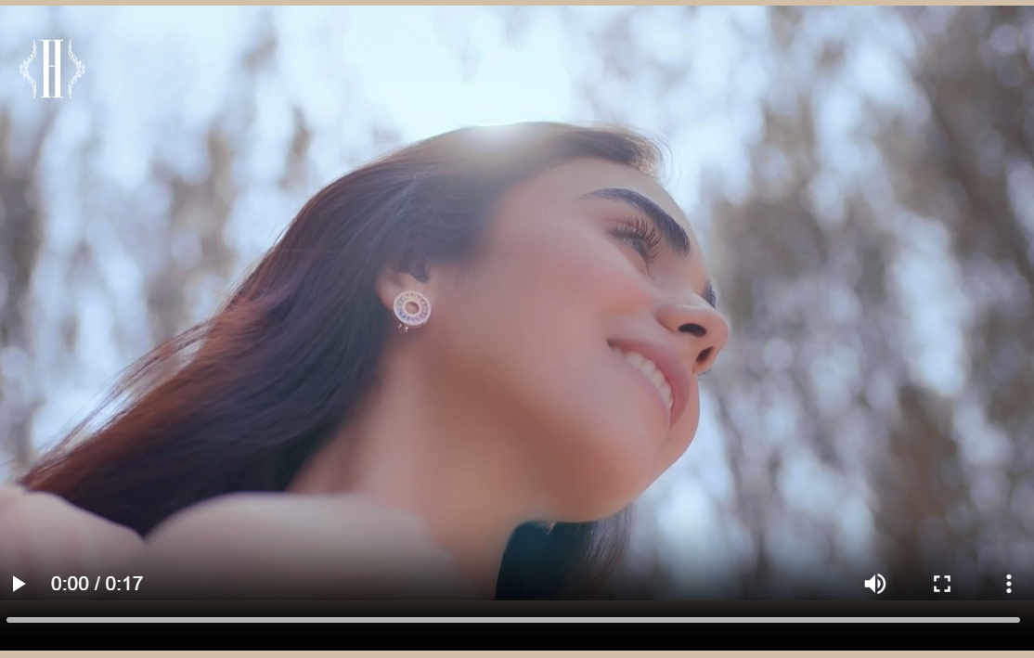

***Figure 7: Linked Video***

***we have put our jewelry website video for the attraction of users***

***8Categories:***



***Figure 8: Categories***

At **Pascal Imitation**, we offer a wide range of jewelry categories to suit every taste, occasion, and budget. Our **Precious Jewelry** collection features elegant pieces crafted with the finest diamonds, gold, and gemstones, perfect for those seeking timeless luxury. The **Semi-Precious Jewelry** category offers beautiful, affordable alternatives, showcasing designs that incorporate stunning stones like amethyst, turquoise, and garnet, ideal for adding a touch of color and sophistication. For those who love modern style at accessible prices, our **Original Jewelry** collection delivers unique, handcrafted pieces with a contemporary flair. Lastly, our **Artificial Jewelry** category provides high-quality, eye-catching pieces that mimic the look of fine jewelry, offering an affordable way to wear the latest trends without compromising on style. Whatever your preference, our diverse categories ensure that there’s something special for everyone at **Pascal Imitation**.

**categories in detail**

***9.semi precious:***

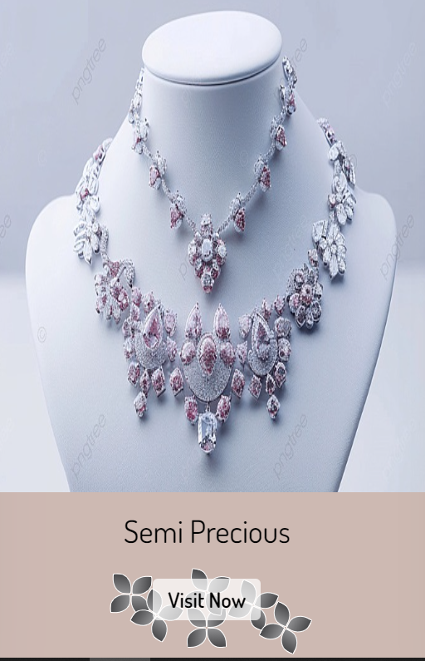

***Figure 8: semi precious***

Semi-precious gemstones are a versatile and affordable way to add beauty and elegance to any jewelry collection. Unlike their precious counterparts, semi-precious stones offer a wide range of colors, textures, and shapes, allowing for a more diverse and creative selection of designs. These stones, which include popular gems like amethyst, turquoise, garnet, and aquamarine, are prized for their stunning visual appeal and unique qualities. At Pascal Imitation, our semi-precious jewelry collections combine the brilliance of these beautiful stones with expert craftsmanship, resulting in pieces that are both eye-catching and timeless. Perfect for those seeking high-quality, affordable luxury, semi-precious gems allow anyone to enjoy the elegance of fine jewelry without compromising on style or budget.

***10.original:***

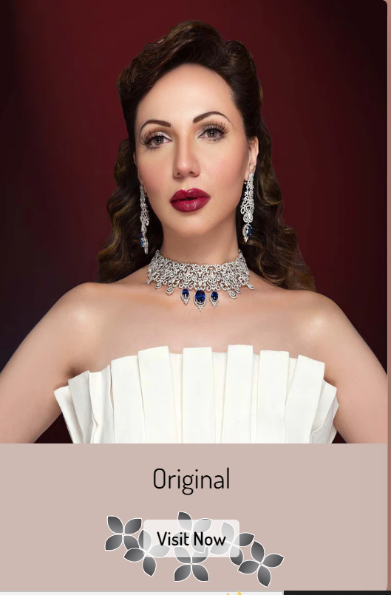

***Figure 10: original***

At **Pascal Imitation**, we believe in the timeless appeal of **original jewelry**, where each piece is a true work of art crafted with the finest materials and unparalleled craftsmanship. Our original collection showcases exceptional designs that go beyond trends, offering jewelry that stands the test of time. Whether made with precious metals, rare gemstones, or intricate detailing, each original piece tells its own unique story. Ideal for those who seek authenticity and elegance, these pieces not only enhance your personal style but also become treasured heirlooms to pass down through generations. With **Pascal Imitation**, you can experience the allure and lasting beauty of original jewelry that reflects the true essence of luxury.

***11.Artificial:***

**

***Figure 11: Artificial***

At **Pascal Imitation**, we believe that beauty doesn’t have to come with a high price tag, which is why we offer an exquisite range of **artificial jewelry** that mirrors the elegance of precious pieces. Our carefully crafted artificial jewelry combines exceptional craftsmanship with stylish designs, giving you the look of luxury without the cost. From shimmering stones to intricate settings, each piece in our collection is made with attention to detail, ensuring you don’t have to compromise on beauty or quality. Whether you're seeking a statement necklace, a delicate bracelet, or a set of sparkling earrings, our artificial jewelry allows you to effortlessly elevate your style for any occasion.

12.***Gallery:***

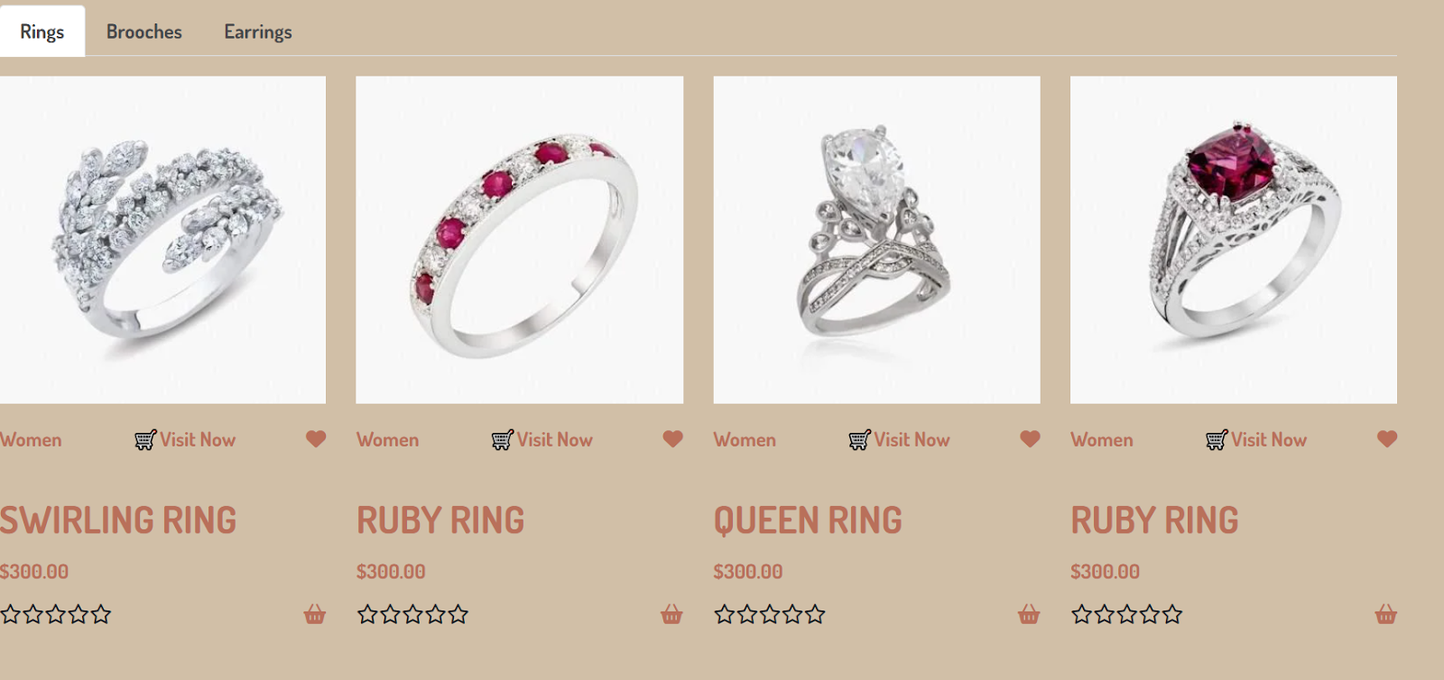

***Figure 12: Gallery***

The Gallery at Pascal Imitation is a curated space where our jewelry collections come to life. Showcasing the beauty, craftsmanship, and elegance of our brands—Velvet Elegance, Velvet Vault, and Velvet Sparkle—the gallery allows you to explore a diverse range of stunning pieces in a visual celebration of style. From breathtaking close-ups to full-length shots that highlight the intricate details of each design, our gallery offers an immersive experience, making it easy to envision how each piece will enhance your personal collection. Whether you're looking for inspiration or simply admiring the artistry, the Pascal Imitation gallery is the perfect place to discover the jewelry that speaks to you.

***13.Contact :***

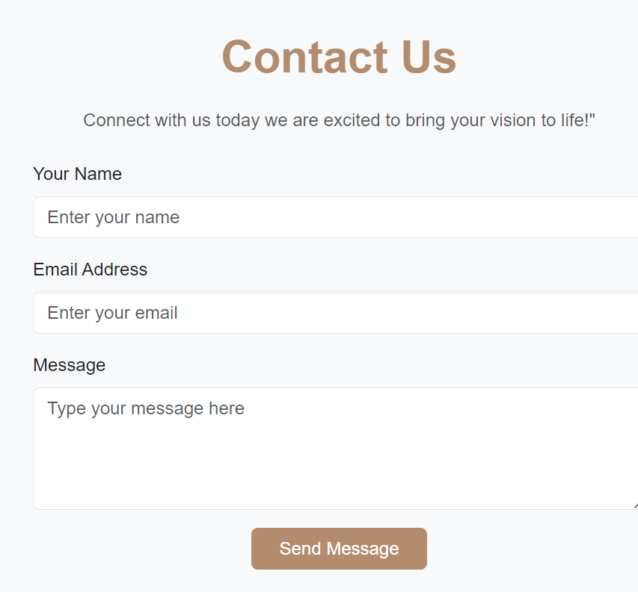

***Figure 13: Contact***

*In our contact section we have given location map for the ease of the people*

*Email id and phone number for contacting in case of any problem.*

*Feedback Form:*

*To know the response of the people our team has given feedback page for the ideas and feedback of the people.*

***14feedback:***

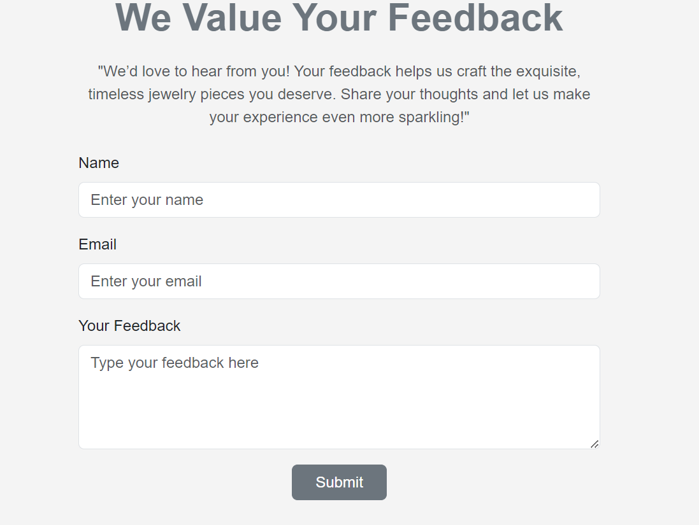

***Figure 14: Footer***

We have given some water bubbles animations in footer to make our website more relaxing.

Copyrights are given in the end of the website and effects of Facebook Instagram and twitter are also mentioned for making the website attractive.

https://lh7-rt.googleusercontent.com/docsz/AD_4nXeNIP75dZ6wtxVnakVQLNFn7ihW74vBV6UUjjx3P25FpzubsxQFW00OzAUzz-PxATEf3WGQ4piXqLD3wPyJguNTtk_EetILqifoz1w_J7vQsyxANNZf0qQw1ik5HR3CncXdHw0BR6qiez4TfzTLG5OwqgEuM4pAjP-fTPb8JA?key=KhdWeQ31oyKcQm8GJSGblk6nhttps://lh7-rt.googleusercontent.com/docsz/AD_4nXf9OIwiV9hPVF8xA6He-whhh2yhekdgM0j2J0Ca5x7XyBl4WKMDZAlNmDbK1iQq2sht0iStHeiHLZAHxnQqEyQeVbEp_h8n-czgDBiIMaks5cXh-S_pQRJMuj58uXPzV4zG6KZ-33PbfeAXliCtewHWc1ibJprKK4c36ye-3A?key=KhdWeQ31oyKcQm8GJSGblk6nhttps://lh7-rt.googleusercontent.com/docsz/AD_4nXd0TUNmetuw8X90snwNTO8pLPdeYjSLzTrUpYMlr4NBBK_mmiDwRv7_X6GhU8vGxsMrxi0Wq5_veA5pnrzPweMj4CxMFwBRcfxiLv1YiR4SMiKSHY2yDJXKO6uibIeiObEt62Q3SrQfsuAJ_K8CqKtIaj9i84-qH8way7BD3A?key=KhdWeQ31oyKcQm8GJSGblk6nhttps://lh7-rt.googleusercontent.com/docsz/AD_4nXc-cQ3nTOausUjLiHXKdx5G2SM9yd9N52tHHjQqtBdkWkkSp-N9vxRd998Iw0eg7Vis5OaNkEEw7EX7iUH31Zr33EiWViGl-Rk3AXvWPnFxJi-I_0YCRBz81JBXXhV4bUGAOEwDa0HqKwbudwp3sENP8lnbVxi-d6C5fFXP?key=KhdWeQ31oyKcQm8GJSGblk6nhttps://lh7-rt.googleusercontent.com/docsz/AD_4nXceFm7bmRGYRy6qEs92PfHEtZj1WUYkIdSV5evT2UzEN8At7RXX5JUmsWDJzMCRKleJI8ZLsl8qtPG2LdHMU5CEz1Yjq5YyyWbchFdSc5HVbIZV3vWRoUOZ0Pf_Rrn_KdVye03ECFgNilH0x2J-OMdingDxTAhgxqQPymd4?key=KhdWeQ31oyKcQm8GJSGblk6nhttps://lh7-rt.googleusercontent.com/docsz/AD_4nXc4MT4KdeszsvQMqTZxyFwPtT_Lw9uwR6_y-l3cQy91h6Eh2WbO_SgA1SJdP5qs094IYRkUPFOudWzlOhU-xPGkM3ZVqQCzj6_5QXuRauQnU_PEGzNFkAsNHTtbbehMtgJopuJaUaYDIp4w7r0SuptEYqH9F5AqMN7W0etp?key=KhdWeQ31oyKcQm8GJSGblk6nhttps://lh7-rt.googleusercontent.com/docsz/AD_4nXd9ipWDuONK4hFMJ3U1rc3ZG140k4FSBY9mQ-vqJIdgImHqkROqX5AsLl4adeab2qxvIZtg0N8tx87SBG8OxsG2ndxYYbgGSSDSTLrbnjLZj10_lUFsJ1sFPaAjDtYHJjjNdcSSCkqRvS8945GVhdzyoHMGkNttI1hJlZa6?key=KhdWeQ31oyKcQm8GJSGblk6nhttps://lh7-rt.googleusercontent.com/docsz/AD_4nXcAvwqJTLJKlofZRYPHitPBg4PaMBfsEOTusUWhUHJKv4wLycGVE1vApSrWo6x-n_-o6X4dQKHNN3bYOpFo2ldbDTGiMiyH6iUxWJxIM30AnmsIXGbWJA-u7lE1BlN6YBT4gAD3dC5P96KXKcQK2XMs-g9vOohghhlGZGoi?key=KhdWeQ31oyKcQm8GJSGblk6nhttps://lh7-rt.googleusercontent.com/docsz/AD_4nXdDvud6Cmd0sBJl0qPHynjUNHwq8tSv3lYV8FK07dx6G75HpGHN3tprM7yAsfzd3PIRKogPfbVOGOtSEguUl5vduX1oolgOYluc_wSjbi2ipoXtwpe2pZZbYu5SyqQUWdOlM0HXm4HoXS98Z2U898A28AWH9ukBWiCaE05k?key=KhdWeQ31oyKcQm8GJSGblk6nhttps://lh7-rt.googleusercontent.com/docsz/AD_4nXffyhgc3_zfPfs8Ij8AwJTFWDC-zG5GunJIWX4UvRmnp9pzv8QXoEngR7qx_X2fMMKv5LUEkUzTaXxx_fKWgxgTplR3ZpS2OmK0pO_mH5gZzOR2EIsqTkXSfNywWsTreEwM868k36OtZ7EbVGM4eggQR441ElAAultGhes7ag?key=KhdWeQ31oyKcQm8GJSGblk6nhttps://lh7-rt.googleusercontent.com/docsz/AD_4nXf5mGHBRor2rx8MRN04tt5e4i8_N3zgoDgBfoVYzzSIytY5lNc4NCju4pgUVOmewf8X0VexnXnASz4nWLcWZlu_HKxOXEo52cAkfxR2aIHfLrK-7mEredB44_k5Z83B-J5KWyz6QtR1rN3cOfJmCmC4pGmZplvPJG81BpuUGg?key=KhdWeQ31oyKcQm8GJSGblk6nhttps://lh7-rt.googleusercontent.com/docsz/AD_4nXfrFUfN-wlyxsEl3qHwvn-maNGD7giNOT2x4cKFWkArXBF-yy3Jp3H3wVzA53SP2zlyqxhn8LWwFaIYHruA9xcsGgS-6ULLLJsvcSsGQwifNusw482tt5Z7niYZuprd7oZ5WekydIV7hQg_t9r0_6mgQ2Edo6ZF9hYMceoQ?key=KhdWeQ31oyKcQm8GJSGblk6nhttps://lh7-rt.googleusercontent.com/docsz/AD_4nXeP46fQlJGoV86BK0kOvl-sR6nP4C2MkNQepNB4jGnLM9p5x67_4ak0wkH_Rgoqmr1YrEhVvYB5JI2UyEADvC2wRUDPpykqSfwQHRkWhN998JLyZAfHPffTAUUWKiNRWyv3D1JHOSQoFmv4FWG3-GUHpgjyBXKWlRQXH_vxtQ?key=KhdWeQ31oyKcQm8GJSGblk6nhttps://lh7-rt.googleusercontent.com/docsz/AD_4nXcj2s4lCH5eJS5Cic5gQTsbJzhqjsNSUbL4AIfCuAHSnrPRAdu_5-p9b35GCPUc6CA_gdWJeL_2csHW2BTUGktT-6wv0WeO-5OVDpra-QZU589pZKPLPXSRYDGzBaFj7fLkh4ScFt1XftI3RAx85q9dnB83WQ6v1ZY8NSz8AA?key=KhdWeQ31oyKcQm8GJSGblk6nhttps://lh7-rt.googleusercontent.com/docsz/AD_4nXdGQa_IkHyfJCx5xIsz8fQWDZDbiL7dWWXErPGi5yJhmEr0wx2xjpuIsKREbI7-k5Td4MR3l3Ct28K9VAil63_P1BF9aVgx7N8URI-YnmL-q-dMQwzN_B25IzEh7u4YkCovdbtX7kUVjKl6vaOLms5trQ-unSuz_fseRNgc-Q?key=KhdWeQ31oyKcQm8GJSGblk6nhttps://lh7-rt.googleusercontent.com/docsz/AD_4nXdbGOCb6_EE2AtesNfc5G7Eh7kQljq5XYIcfaJTAPF1SOibeSgAkUVsWBOyobOwYUfLwBhZBxSgzN2GG4QImtzejgrdvRYWE7NjrHPXCGlU_qnQb4nTcVICfbfi7qFAgJoVTAc89fjbafR00TNTJDnQTqPqvaSDAsPPLwgTtw?key=KhdWeQ31oyKcQm8GJSGblk6nhttps://lh7-rt.googleusercontent.com/docsz/AD_4nXdosw8ZM8GU1233yanqZVAs0xjTEWQ5ur0synI0pRV3pjWeSg9e6IBD-_qUCcqWpSTYFeJ_IWYaVuCLr8ZU11pskhKQJTOoF9E_qJks3ZcpZ-ECr08iPCZ5bP6KmRBd6q3Nve9hZgjUNmA-F8R9S4zkf7TMRpeSTLTvCocUQA?key=KhdWeQ31oyKcQm8GJSGblk6nhttps://lh7-rt.googleusercontent.com/docsz/AD_4nXfWZ5t1CZPqIRV46wRnPzlYuRrDTPku7yAvhaEqFoF0XzOkSDk0gzLQTEZ50kqegs9h_7paS5kcouwEiPafYB2cv9HmBl4_j167VIOr52ECKmjSYD_Xl2uGq-uI9rZMGkFfVdYScN-2FxbxiJEdied0c-wB17CM0hP-fCVD?key=KhdWeQ31oyKcQm8GJSGblk6nhttps://lh7-rt.googleusercontent.com/docsz/AD_4nXe3hPDT-jubziUWmrBxwTCkHnMZRG7Mg0OIfTbOIlQAWGIf-nY7b8FlKWCpa-TAZDbCPeaL91FMWZ77knVcI0ubfhf2R2j37Ta3rz4jYTwW2m7cxOoW1wkgNz6cMXX6V2KSRhZ7q_8SYR1OZZ9bhVDWjF6ewsaU59vUJFDluA?key=KhdWeQ31oyKcQm8GJSGblk6nhttps://lh7-rt.googleusercontent.com/docsz/AD_4nXfwRKxGYs0tfc-PmogwT1mvEMBpe92zBeBuTUogy8BftZkefkd8X4jnMNIb2GhXKUfR4TT2QRblPrlgcLCHP0pC-kD4z4YKOU77QnMhy9nN6w_AAdjMpt0KjJPvS_L8UEofzXwl8rv-CmG47RxTH7vhUSiwSzDiotBhuLKqbA?key=KhdWeQ31oyKcQm8GJSGblk6nhttps://lh7-rt.googleusercontent.com/docsz/AD_4nXdcpDuhxvM14420jcLdYMjo7zckukgZ0ikaretF-uGBitLk-NYQii6MM9wE0RSUAWjK9u4_U4_JGdpVTeAfsxY3gJoW7IhwYRb1qbMYYsDhP5Yvqe3h3MoZpAakDIK0sRIlRCetAN39VkB7ZAqDPi1ntGoIUtweuP23kXYOPw?key=KhdWeQ31oyKcQm8GJSGblk6nhttps://lh7-rt.googleusercontent.com/docsz/AD_4nXeSowoAGSJEG2fDBDwnHPnqkgXU450ydOdZOo9R0fv5FUS7QR4hC2sTsN4mE6chNvK5t5sd2Roh0su0V-d5w9WGIh3eJKmfi39AIIzFQuBVnc9RWpuGe_asMx6xi9OA-iMs27jsI7JBTUVUIhV6rt2dDif_iIsjpHn0jgUT?key=KhdWeQ31oyKcQm8GJSGblk6nhttps://lh7-rt.googleusercontent.com/docsz/AD_4nXdpyhylx5RlEmSsh91_Drqhpn7PSwRLqtZqxv1XRtEcruvemAzQ0eXnSBqMfXMvd7IgAVflt-e8t1gb6DukYeC0H1YmJVnGKoADPZyfB7Gslh4rhjutLhx5ecjZMJ3GZJBXrHhSpXoxyE_VCUha7ah3W2e7L-DsZdFsnOP-JA?key=KhdWeQ31oyKcQm8GJSGblk6nhttps://lh7-rt.googleusercontent.com/docsz/AD_4nXdQyjUnidnntIZsjLhqn3dAf2Hm7rQ1hTjD4DzH7PauBGtpSBoZFn0HkLml4TC7KadC48FyRe9bK9N8YMjdIP8PCK0mSZMlW1_m2pNAWjCrdS98kDqlwu5HdUu8xLl9znLVSegLZgv1om7s-Lt_Hs8MFNmtgu8mhldFWUIuPw?key=KhdWeQ31oyKcQm8GJSGblk6nhttps://lh7-rt.googleusercontent.com/docsz/AD_4nXfk-GKym3tc5lP9ItzG0p2f1E0r6EqPcyA8jem0hSdDH9eo3w4cyK5-azUtTqolDLqaxQXacfmUYd2TEIor4dB8X431oiIhzV9lkZWIXRjMJuiI8F9aLzl6bt2iVcqOZcYPkcKg8dE7TPcdXKgcCz8roCX52uZvm3IkKcvO?key=KhdWeQ31oyKcQm8GJSGblk6nhttps://lh7-rt.googleusercontent.com/docsz/AD_4nXfJ-RRXFL9pC4V_TO5O-SYUVNVqGjieUN1luT09gW4qkzmSKQAcpHZU7tWA0E9oT3CCD267gjEs4JbMnC-SQz_bkFKdF7RaIuemILntkLbQFfSS6UwTbN-Xq1-UCoJG8E8sQEXz-8WR4bQn1x4ZG6SkP4t2XU4yhG9_2D9YJw?key=KhdWeQ31oyKcQm8GJSGblk6nhttps://lh7-rt.googleusercontent.com/docsz/AD_4nXcAFxzUwRntNRw_6Qy-Tx9aOCTM4mz94AGa8rz5BvHY79V3nCJK3ZpKkuJ3u6Rx-Le3FT7D8czvLLkfsx6jFmuQDeejzp5bBUL2Qd9iH2_nj9st088dgCjMxX06KDXqcuxoJitnxDorAUoFdbdMLjb-VyWQY7qt11QO0F2gBQ?key=KhdWeQ31oyKcQm8GJSGblk6nhttps://lh7-rt.googleusercontent.com/docsz/AD_4nXcEZGWNyZW3M17FAilEMmY-H5AJWIrLAs4eaPy_3V2aGkOYJXvkQIaYv1OklVc_jNncm6eQsyIddvX1uCwMVzjC4sRH8rYG4rUvLsFizfpb4FLDOIvhbyHpwJIgzOVtrOVEvFctePPRhkuCcSFmKyAigCBQOF-TvkNc59ZKrA?key=KhdWeQ31oyKcQm8GJSGblk6nhttps://lh7-rt.googleusercontent.com/docsz/AD_4nXeopP4oSLLbCtqEUqZUZ_uGC2MTh-16daqf4MBpAO8oqvoY3Vfia7cucurqzlHtEZoZPh_0rcIOtG2m3G8mLs-q0rBUqjduyKWU5HMkESUz717bcbg1hFh77tZ_Bt0XQ_0yTK2U0sSBOR8tU-QarjwL6QiUlQgygxDpnS4-og?key=KhdWeQ31oyKcQm8GJSGblk6nhttps://lh7-rt.googleusercontent.com/docsz/AD_4nXfC2i7T3s2-3f4OasMWOWU9u2OlzaS-QX8dP3_5dtsLq5QSZ7zeTLi3YshFdxGNIldr5xjErzFJWb7-JqWLeJywKQi0F8YqTIThuBDAFHnrMNt55i0udm4xfTv2AARs_gGRelKqeEtE85wMV2Tn_V9sYL0XU4ubLqLjri5e?key=KhdWeQ31oyKcQm8GJSGblk6nhttps://lh7-rt.googleusercontent.com/docsz/AD_4nXcVhBHrjaV-6sBl_KxPjPQPoh3aPPkcsro8ig54Q7UofNuj34_az8PcfXXWKYypy7XpyVBb2jnEt9gDGbCLO4y8qNg1ZQYFGFP279IJ2pAqOFDyLSU89e-Fho6wKgiZ-5Xe0MHfyoStH4zSvADCKnzLASzZ1P8bO3z3Xm8WlQ?key=KhdWeQ31oyKcQm8GJSGblk6nhttps://lh7-rt.googleusercontent.com/docsz/AD_4nXfT5OLvpwTfEPs33iXomK2Fs6wCCZc2ZOl19uOjo-X2T2GWF1u25gGftkRxr-lSFBeOB92PGIQ_C5WVO3V1bhJcEZsP-VWgWILnrb2sjYpQuumZqZdCbnbhNUbQswhxrXvY72GzvcwwZzwYLUNpcCPxY5v_zRvCGzk2Mz5RUQ?key=KhdWeQ31oyKcQm8GJSGblk6nhttps://lh7-rt.googleusercontent.com/docsz/AD_4nXe4wKYhOgs7no80PtRPivtywhc0Sp4pyI_NqM0-HDD3sFJp0LXEoN-czoaDXOhYxRXfHDahm8pQLzo2UA7y6rndGOe0Kbb1WE0DzaTOt-ykeUUGXYPnwSq-2wPS3djV9XwCgBfkhZHxE8UyObmukgscWK6HutN5mhouvhDb3g?key=KhdWeQ31oyKcQm8GJSGblk6nhttps://lh7-rt.googleusercontent.com/docsz/AD_4nXe2CDxQYPIJvWQ6oKMh4rTtcL7F_JOJu2i2kTahISc42-ZH7PqVvMbv8LhAo6nIX8jL9F2t0Fcwig8qsrL776wY7sXc65mvV1oFP1ngc4G5WvitIr_NFr8TcYiPFm02pS30nPv0ba3anFHqiPPl7VFWy34auyWSm_sHwHI0jg?key=KhdWeQ31oyKcQm8GJSGblk6nhttps://lh7-rt.googleusercontent.com/docsz/AD_4nXcxQJx1X_grzh4l0p7TjgEQdwl7aHOEHgoUXsLOQXF8gM9-Sc89uGbHMJuTkHX0VTjlIsaDHkERVpMaXKOHdamydmVXWyQTzFDtUqvvC_khNuR_1j-qhsloMW93gqWYPSEExkyOLgcG6h2cl53rv2zi4g4uHvS6ns1QqsstNg?key=KhdWeQ31oyKcQm8GJSGblk6nhttps://lh7-rt.googleusercontent.com/docsz/AD_4nXcv_3_Wv7v_iSjtEQt2rvocekIJmBCQLcnhQqskND0gNJZdG1hKNFh2Jri6mNcnLWtxJkbuIm24VYWS2VGiF09B-eQkGxE8pmC7lRN-tAals5MHxBWpTIMcgIA58D_DzLBIbU6Y1D-K8LukPFNcBO8T4CNYNDkpc-S1eFuzbg?key=KhdWeQ31oyKcQm8GJSGblk6nhttps://lh7-rt.googleusercontent.com/docsz/AD_4nXcUyQJXc44e06D7C5brDD-y_o4sqN_Z19iEMQRB0j-WcnmDBr5cIm02kuQem8eiuNJAR_IABBS9arT8Jy8qzktlqj_PDESke6ZxsdTAi5US71MSuaZNpjkMv3eCDraAohVrg82J4bLfI8bHsT9EceEz2og7Po-DBd5wWC79Hw?key=KhdWeQ31oyKcQm8GJSGblk6nhttps://lh7-rt.googleusercontent.com/docsz/AD_4nXd0hvcH-UoK93JV9NvZ4pjbH7QdyTMAc09dxKszh-uCzGS1iCx8FI0otdC0FQdL_2ZkSH0PVUrxX7x9WvzLfj2KlcHUnjpmH9sOYyRH1nr22PebeWipVdrPHWmSfyyYU5T6kHuk13rM5iXuYsN38wpkRq6hzjXmNQSxRTKM-A?key=KhdWeQ31oyKcQm8GJSGblk6nhttps://lh7-rt.googleusercontent.com/docsz/AD_4nXeN---NwaQ-jCyMOpbiParc_fC5jUASIbVeeA2ar14mqE-kjznTx_rcDU8OeOCZDvj_LCG-bw-VvhdpTl6zLbv-FOvX6ZGF8Mt8_RHFOqB_-nfFJPgH1VNWj9mOMpNAxvY6cpgbsC6S1xCumpLGuXlUrry3kECLQloPyEuA0w?key=KhdWeQ31oyKcQm8GJSGblk6nhttps://lh7-rt.googleusercontent.com/docsz/AD_4nXcMFVEshCZ9CSEOS2HY2TTupjE0gCdDXytRpN-POnAFoatoII_ojWm3CeSkMkhoFCgE1S_Fq5fafE5OFqulInNBb6DZPSewvLuecxgE13CNuJU4sc3ir8G_KFja9N5XM01ftK7gV7GUwDcx0I_atfLVVaRQLlGc38WK6pmmRA?key=KhdWeQ31oyKcQm8GJSGblk6nhttps://lh7-rt.googleusercontent.com/docsz/AD_4nXdxULkW1vyciCk5pFrdJbp8_p10Z4elKwHB7lQ2De1jJ8NaAiw41sr484iyVwve_ukHBgnTFjkC1qBQsomndz0_FpzVSaKkNyQzCZkn5inAhnbtqCZ7iU0bhP4E-6lXOjSR1JozsH7Am28H2bRGnnv42T2RgENncvXH4ihpIw?key=KhdWeQ31oyKcQm8GJSGblk6nhttps://lh7-rt.googleusercontent.com/docsz/AD_4nXcAVl0Pq8x9GnHA0qqVKNtBLXer_8hzldeqnbmL2hfZC3XH9EvpA9llp8zu5Xzdq4fVjD8j1bb0xIyefF09CYmZE5Ky_gJGyxImMmnF1wEkTBYB6R38njxPNwvtAZa6jYM7StZfj7x2ZpiymR8HZOHjHtNMj2T1Rcdq0YeGFg?key=KhdWeQ31oyKcQm8GJSGblk6nhttps://lh7-rt.googleusercontent.com/docsz/AD_4nXdVVvp2MyqWwo2qJkfSP23GOR-ZVnu5OKU0xUago0h-mlzFYxXWfUwT6-LcBdiXVNP6qLRDmQ2V6Tk0_frcFZW44CIBPHDH9tmr0L2zlEah_FmPabBxZCLfIRNH9cN2176GBsnuD7HKeEVVUBdG3IuxqmSKyXieIOg8j1ZD9A?key=KhdWeQ31oyKcQm8GJSGblk6n